Kidcare-International
H e l p i n g c h i l d r e n , s t r e n g t h e n i n g f a m i l i e s ,
suppor ting communities worldw ide in Jesu s name
I W O ULD LIKE T O HELP KID CARE :-
Please tick Choices. THANK YOU
Please give any amount you can afford in any of the following areas:-
Section 1.
By being a BENEFACTOR to Kidcare and giving to areas where needed on a monthly basis. Please fill sections 4 and 5 and if you can 6
Section 2. By supporting a Kidcare Project(s) as a KIDCARE PARTNER on a monthly basis. Please tick your choice and fill sections 4 and 5 and if you can 6
- Supporting a children’s home in Kenya, Uganda or Philipines
- Feeding children in schools in Kenya, Ghana, Uganda or South Africa Assisting Kidcare supported schools to educate childen in impoverished areas or villages in Kenya, Uganda or Ghana
- Supporting health centres and maternity units in impoverished areas
- Support KEEP:- Kidcare Economic Empowerment Program, by giving micro loans and training to help poor families to engage in small businesses ventures to support their children.
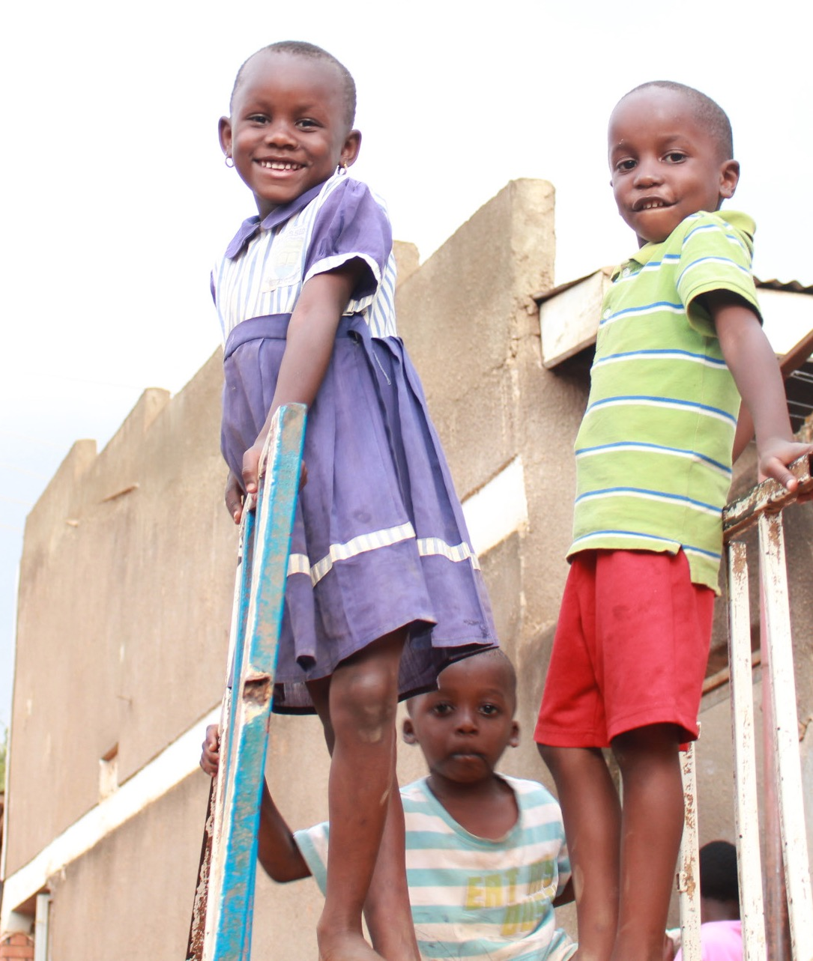
Section 3. By Sponsoring a Child and donating on a monthly basis. Please tick your choice and fill sections 4 and 5 and if you can 6
in Kenya, Uganda, Ghana
£26 to primary school
£36 to secondary school
£36 in a children’s home
Section 4 MY DETAILS. Please state your
NAME:
ADDRESS :
POSTCODE:
TELEPHONE
EMAIL

Section 5 STANDING ORDER. I would like to make a monthly gift
I will do this online and inform Kidcare International.
Or please fill in the form below and email this back to us
Instruction to your bank or building society to pay each month by standing order
To the Manager of ....................................................
Branch address:-.........................................................................................................
ACCOUNT NUMBER...........................................................
SORT CODE ...........................
Please pay, Kidcare International Lloyds Bank, Caterham
SORT CODE 30 91 72 ACCOUNT NUMBER 03030050
the sum of £ every month (until you receive further notice from me/us)
First payment of £ on the 1st, 8th , 15th or 28th of (state month) (please circle your preferred date for which payment should leave your account).
Signature(s):..................................................................Date:...........................................

Section 6 Gift aid
YOU CAN GIFT 25% MORE AT NO EXTRA COST.
Please make sure your home address is given in section 1 above.
I am a tax payer and want Kidcare International to claim tax on any donations that I have made in the last 4 years or from .............................. and all donations I make in the future. I understand that I must pay an amount of income tax and/or capital gains tax for each tax year that is at least equal to the amount of tax that all the charities that I donate to will reclaim on my gifts for that
tax year.
Signature(s):..................................................................
Date:...........................................

Thank you for your support
KIDCARE INTERNATIONAL, S BC House, Restmor Way, Wallington, Surrey, SM6 7AH, info@kidcareinternational.co.uk
Tel./Fax 0203 417 5727 or 07724711700
Registered Charity number 1118180 and a nonprofit private limited company, Registered number 5968235.

